**Database Course**

**Final Project – Step 3 – E-R diagram (with Crow’s Foot notation) – 8 points**

**Deadline: 28 April (Sunday) 9 pm**

**Instructions: In this assignment, you will demonstrate your understanding of database design principles by creating an Entity-Relationship Diagram (ERD) for your database project.**

* **Create a visual ERD diagram using a diagramming tool of your choice. You can use MS-Word, MS-PowerPoint, LucidChart, Visio and Draw.io.**
* **I recommend using Draw.io (https://app.diagrams.net/) where you can find 'Entity Relation' at the bottom left of the page. There are many alternatives available under that option. Under the 'File' menu, you can locate 'Save.' Choose the following steps to download your diagram to your computer.**

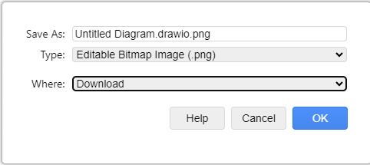

* **Then copy/paste your diagram into this MS-Word file, save it, and upload it to the LMS.**
* **Remember that we follow Crow’s Foot notation in this class. Other notations will not be accepted.**
* **Make sure that your data dictionary and ERD are fully matching.**
* **Do not forget to fill out the table below.**

|  |  |
| --- | --- |
| **Team Member(s):** | **202110647 junhyung-kim** |
| **Project Topic:** | **Film Festival Management System for organizing film festivals** |
|  |  |

